
BachelorProject

PROJECT TITLE:Shop Management System
 |  | NAME: Asadul Islam |  |  | ID:143-35-811
 |  | Section |  |  | B
 |  | Supervisor Name |  | ： | Aalamgir Kabir Sagar
 |  | Department: |  | ： | Software Engineering
 |  | Faculty of Science and Information Technology
December 2017
Table of Contents
Chapter 1 1
1. Introduction 1
1.1 About the System 1
1.2 Purpose 1
1.3 Scope 1
1.4 Vision 1 Why this system is necessary? 1
1.6 Proposed Solution 1
Chapter 2 1
2. System Analysis 1
2.1 Use Case Model 1
2.2 Actor Goal List 1
2.2.1 Admin 1
2.2.2 Customer-------------------------------------------------------------------------------------------------1
2.2.3 Cashier---------------------------------------------------------------------------------------------------2
2.3 Use Case Model 2
2.4 Use Case Description (Brief) 2
Use Case Description (Brief)------------------------------------------------------------------------------3
Use Case Description (Brief)-----------------------------------------------------------------------------4
2.4.1 Sales Daily product(Example) 5
2.5 Use Case Description (Detailed)-------------------------------------------------------------6
2.5.1 Sales Daily product(Example)------------------------------------------------------------------------6
2.5.2 Stock Product(Example)-------------------------------------------------------------------------------6
2.5.3 use case description (detail)----------------------------------------------------------------------------7
2.5.4 Stock product (example)--------------------------------------------------------------------------------7
2.5.5 value per product (example)--------------------------------------------------------------------------8
2.5.5 Use case description (detail)-------------------------------------------------------------------------- 8
2.5.6 Value per product (example)--------------------------------------------------------------------------8
2.5.7 Calculate profit or loss(example)---------------------------------------------------------------------9
2.5.8 Use case description (detail)--------------------------------------------------------------------------9
2.5.9 Calculate profit or loss (example)-------------------------------------------------------------------9
2.5.10 Purchase product (example)-----------------------------------------------------------------------10
2.5.10 Use Case Description (Detail)----------------------------------------------------------------------10
2.5.11 Purchase product(example)----------------------------------------------------------------------10
2.5.12 Give payment (example)---------------------------------------------------------------------------10

2.5.13 Use case description (detail)---------------------------------------------------------------------11
2.5.14 Give payment (example)-------------------------------------------------------------------------11
2.5.15 Receive money (example)------------------------------------------------------------------------11
2.5.16 Use case description (detail)---------------------------------------------------------------------12
2.5.17 Receive money( example)------------------------------------------------------------------------12

2.6 System Sequence Diagrams 12
System Sequence Diagrams-------------------------------------------------------------------------13
System Sequence Diagrams-----------------------------------------------------------------------14
System Sequence Diagrams-----------------------------------------------------------------------15
System Sequence Diagrams-----------------------------------------------------------------------16
2.6.1 Purchase new products--------------------------------------------------------------------------------------16
2.6.2 Login------------------------------------------------------------------------------------------------------------18
2.6.3 Choose product-------------------------------------------------------------------------------------------------18
2.6.4 Give Payment----------------------------------------------------------------------------------------------------19
2.6.5 Make new sale---------------------------------------------------------------------------------------------------19
2.6.6 Enter item--------------------------------------------------------------------------------------------------------20
2.6.7 End sale-----------------------------------------------------------------------------------------------------------20
2.6.8 Make paymenet-------------------------------------------------------------------------------------------------21
2.6.9 View daily sales products-------------------------------------------------------------------------------------21
2.6.10 Stock product--------------------------------------------------------------------------------------------------22
2.6.11 Fixed value per producccts---------------------------------------------------------------------------------23
2.6.12 Calculate profit or loss---------------------------------------------------------------------------------------24
2.7 Domain/Conceptual Model 24
2.8 Activity diagram 25
Chapter 3 25
3. System Design 26
3.1 Sequence Diagrams 26
Sequence Diagrams----------------------------------------------------------------------------------------27
Sequence Diagrams----------------------------------------------------------------------------------------28
3.1.1 see stock product 29
3.1.2 value per product-----------------------------------------------------------------------------------------30
3.1.3 See profit or loss------------------------------------------------------------------------------------------31
3.1.4 See daily profit or loss-----------------------------------------------------------------------------------32
3.1.5 Payment rate----------------------------------------------------------------------------------------------33
3.1.6 Create memo---------------------------------------------------------------------------------------------34

3.2 Class Diagram 34
3.3 Entity Relationship Diagram 35
Chapter 4 36
4. Implementation 36
4.1 Tools &Technologies 36
4.2 Project Link 36
Chapter 5 36
5. System Testing 37
5.1 Why Software Testing is Essential? 37
5.1.1 Black box testing 37
5.1.2 White box testing 37
5.2 Test Cases 37
5.2.1 Test case: Sign up 37
Chapter 6 37
6. Conclusion 38
6.1 Good Features of the System 38
6.2 Limitations of the System 38
6.3 Future Enhancements 38
Appendices 39
7. User Manual 40
7.1 Log in Screen of Federal Shariat Court Case Flow Automation System. 40
8. References 41

Chapter 1
Introduction

1.Introduction

1.1 About the System
Background:
From a super shop customers have to buy different product according to chose their item,item category,item color,item size and item price according to user demand. It is very difficult for customer to buy product according to their choice and acceptence and need a lot of time to buy the product. Admin need to know the "daily sales data","Current Stock","item wise current value" table Query. It also needs to calculate profit or loss according to their buying and sell price.It is also very difficult for admin to know daily sales,current stok and item wise value.So I want to make Shop management system in order to get customers demandable product easily and timely and Management can easily manage the shop.

1.2 Purpose
Main purposes is that manage the all work of the super shop. Here customer will purchase product and he will pay money to the Cashier.Cashier will receive the money .Here system will give a invoice or or mamo that will generate automaticaly by the system and will save the customer information and details. Admin can know the "daily sales data","Current Stock","item wise current value"table Query. In this system it can be calculate all the needed figure at a time , like company profit or loss.

1.3 Scope
.Easily choose product
.Get product in timely manner
.Save time and cost
.Calculate profit or loss
.Save information of customer details
.Give percentage of selling product

1.4 Vision
1.5 Why this system is necessary ?
This system is necessary to manage all kinds of super shop so that it is possible to reduce complexity of buying products,get easily product ,save maoney and time and can increase the profit of

Chapter 2
System Analysis
2.System Analysis
2.1:Use case Model

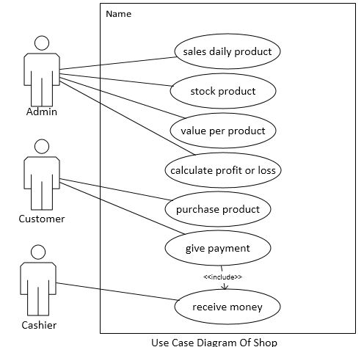
2.2 Actor Goal List
2.2.1 Admin
.Observe and views sells daily product
.If there is no product ,admin can stock of the product
.Fix value of the per product
.According to daily sell admin can calculate profit or loss

2.2.2 Customer
.Go to the shop
Login the system
.View the product
.Order the product
.Purchase the product
.Payment for the product

2.2.3.Cashier
.Receive money
.Give exchange to the customer
.Give recit or cash memo

2.3 Use Case Model

2.4 Use Case Description (Brief)

Description of use case 1:Sales daily product
1.Use case name:Shop Management System
2.Goal:Admin will see the daily sales product and will know how many product has sold.
3.Actor:Customer, Admin ,Cashier.
4.Stakeholders:Shop Management System.
5.Pre-condition:Befroe sales daily product have to bring the product from the supplier ,have to store it acccording to item wise and then have to sell it.
6.Post-conditon:After selling the daily sales product have to know how many product sell ,have to receive money and have to give memo to the customer

Success secnerio:
1.Management will buy thte product from the wholeseller and have to store the product.
2.Display the item according to category.
3.Customer will choose the product
4.Admin will determine the price
5.Cashier will receive the money and will confirm the sell.
Alternative flow:
1.Management have not storage the product
2.Management can not display the item according to category
3.Customer can not choose product

Description of use case 2:Stock
1.Use case name:Shop Management System
2.Goal:Admin will see the how many stock.If there is no stock ,Admin will order product from wholeseller.
3.Actor:Customer, Admin ,Cashier.
4.Stakeholders:Shop Management System.
5.Pre-condition:Before stokeing admin will first order productand will pay money for the product.
6.Post-condition:After stockng the product management will trt to sell the storage product according to item wise category.

Successs secenerio:
1.Admin will give order for product to the wholeseller
2.Admin will payment for the product to the wholesller
3.Admin will kepp the producrt item wise
4.Customer will show the product storage
5.Customer will buy the product from storage
Alternative flow:
1 Admin can not give order for product to the wholeseller
2.Admin can not kepp the producrt item wise
3.Management can not storeage product.

Description of use case 3:value per product
1.Use case name:Shop Management System
2.Goal:Admin will see the per product value so that he can the product item wise price and sell the product with that price.
3.Actor:Customer, Admin ,Cashier.
4.Stakeholders:Shop Management System.
5.Pre-condition:Before giving the per product value have to consider manufacturer cost and have to see the market price.
6.Post-condition:After determing the value per product have to sell the product with that fixed price to the customer.

Success secenerio:
1.Admin will fixed the product value
2.Admin will buy product to the customer.
3.Customer will buy product with that price
Alternative flow:
1.Admin can not fix the product price.
2.Customer can not buy the product with that fixed price.

Description of use case 4:Calculate profit or loss
1.Use case name:Shop Management System
2.Goal:According to daily sale per product Admin will know the profit or loss
3.Actor:Customer, Admin ,Cashier.
4.Stakeholders:Shop Management System
5.Pre-conditon:Before calculating profit or loss it must have to consider how many product has sold according to per product value
6.Post-condition:After calculating profit or loss it must have to consider which product is profitable that product will be ordered have to try to increase the profit.
Success secenerio:
1.Admin will sell the daily product
2.Admin will fix the price according to product category
3.Customer will buy the product
4.Customer will payment per product value
5.Sytem will give a cash memo
6.System will calculate profit or loss

Alternative fllow:
1.Admin can not sell the daily product
2. Customer can not buy the product according to iem wise category
3.system can not calculate profit or loss.

Description of use case 5:Purchase product
1.Use case name:Shop Management System
2.Goal:Customer can purchase product according to their expectation and can get their expected product in time.
3.Actor:Customer, Admin ,Cashier.
4.Stakeholders:Shop Management System.
5.Pre-condition:Before purchaseing they have to fix a budget,havt to choose the product item.
6.Post-condition:After ppurchaseing the product customer will use the product and can know the product is bbenifitted or not,long existing or not.

Success secenerio:
1.Customer goes to shop and select item
2.Go to cashier
3.Cashier sum the bill
4.Customer payment
5.Cashier return handles
Alternative flow:
1.Customer can not go to shop and can not select item
2.Cashier can not sum the bill
3.Cashier can not return handles

Description of use case 6:Payment
1.Use case name:Shop Management System
2.Goal:Customer will pay the bill to buy a product
3.Actor:Customer, Admin ,Cashier.
4.Stakeholders:Shop Management System.
5.Pre-condition:Before payment customer will go to the cashier and will pay the bill
6.Post-condition:After payment customer will get the product and cash memo

Succcess secnerio:
1.Customer choose the product
2.Customer will buy the product
3.Customer will payment to the cashier
4.Cashier give a memo to the customer

Alternative flow:
1.Customer can not buy the product
2.Customer can not pay to the cashier
3.Customer can not get a cash memo

Description of use case 7:receive money
1.Use case name:Shop Management System
2.Goal:Cashier will receive money from the customer and handles to the customer
3.Actor:Customer, Admin ,Cashier.
4.Stakeholders:Shop Management System.
5.Pre-condition:Before receive money cashier will ready to take the money
6.Post-condition:After receiving money cashier will handle the exchange and will give the cash memo.

Success Seceneriio:
1.Cashier will sit the cash
2.Cashier can receive the money
3.Cashier can exchange the money
4.Customer can get cash memo

Alternative flow:
1.Cashier can not sit the cash
2.Cashier can not receive the money
3.Customer can not get cash memo

2.4.1 Sales daily product( example)
Seller of this system can sell the product.He can stock the product and also sell sell current stock product.
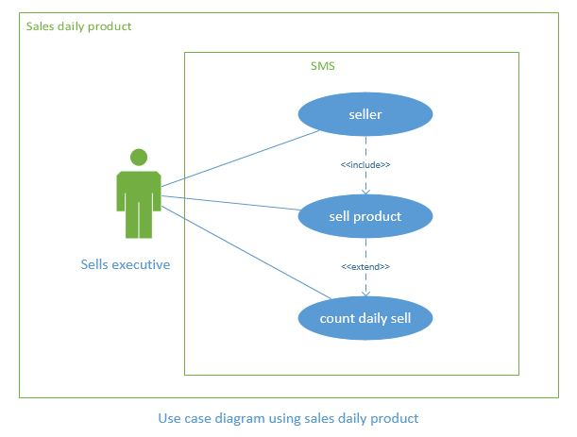

2.5 Use Case description (detailed)
2.5.1 Sales daily product (example)

1 Sales daily product (Example)
Use Case ID | 1
Name | Sales daily product
Primary Actor | Sells Executive
Secondary Actor | Customer
Goal | 1 Sales daily product to the different users
Precondition | Product is stored in database and display the product
Post Condition | View product,choose prodct and then buy the product
Main Success Scenario | 1.Sells executive display the product  2.Customer view the product  3.customer choose the product  4.seller sell the product  5.Seller count the daily sell product
Scenario Extensions | - Customer can not view the product  - customerr can not choose the product  3.Seller can not sell the product

    - Stock product (example)
Admin of this system can stock product and can see the current stock of the product

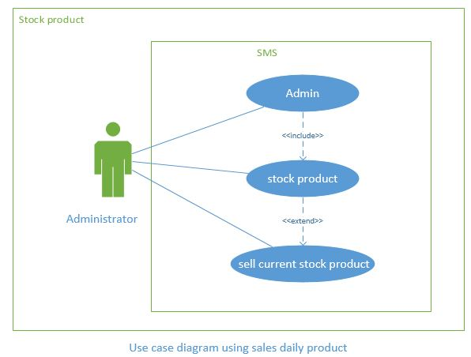
    - use case description (detail)
    - Stock product (example)

Use Case ID | 2
Name | Stock product
Primary Actor | Administrator
Secondary Actor | Cashier
Goal | 1 Stock product to the cashier and customer
Precondition | Check the stock is empty or not.
Post Condition | Sell the product to the customer
Main Success Scenario | 1.Admin check the stock  2.Admin stock the product  3.Customer will see the stock product  4.Customer choose the proct  5.Customer buy the product
Scenario Extensions | 1.Admin can not check the stock  2.Customer can not view the product  3.Customer can not buy the product

2.5.5value per product (example)
Admin of the system can see the daily sales product and can calculate profit or loss.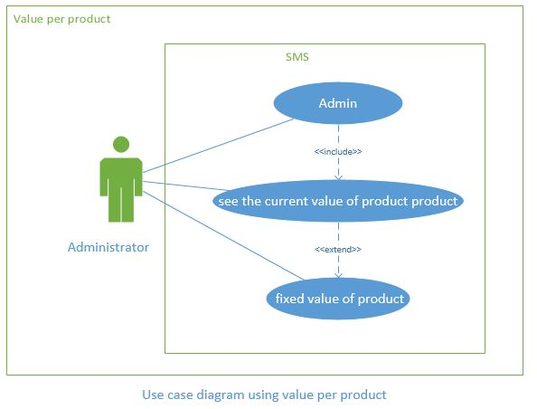
    - Use case description (detail)
    - Value per product (example)

Use Case ID | 3
Name | Value per product
Primary Actor | Administrator
Secondary Actor | Cashier
Goal | Fixed value of the per product
Precondition | Consider the buying price,current product market value
Post Condition | Sell the product with that fixed price
Main Success Scenario | 1.Admin fixed the value of per product  2.Customer will view the product price  3.Customer will choose any fixed price product  4.Customer can buy any fixed price product
Scenario Extensions | 1.Admin can not fixed the product value  2.Customer can not see the product value  3.Customer can not buy the fixed price product

    - Calculate profit or loss(example)
Admin of the system can see the daily sell product and can calculate profit or loss
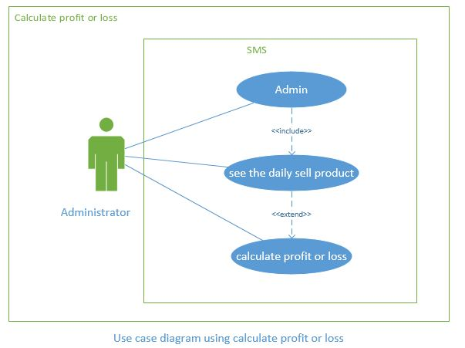
    - Use case description (detail)
    - Calculate profit or loss (example)

Use Case ID | 4
Name | Calculate profit or loss
Primary Actor | Administrator
Secondary Actor | Cashier
Goal | Admin calculate profit or loos o the selling product
Precondition | See the daily sell product
Post Condition | Analysis how to increase the profit
Main Success Scenario | 1.Adnmin will see the daily sell product  2Admin will Count the daily sale product  3Admin will calculate the profit or loss of the product
Scenario Extensions | 1.Admin can not,see the daily sell product  2.Admin can not calculate profit or loss

2.5.10 Purchase product (example)
Customer can view the product list and can purchase product.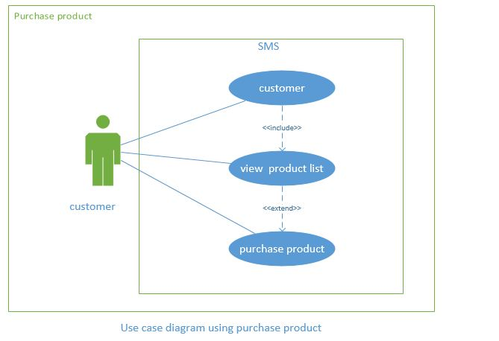
    - Use case descripton (detail)
    - Purchase product(example)
Use Case ID | 5
Name | Purchase product
Primary Actor | customer
Secondary Actor | Null
Goal | Customer purchase product
Precondition | Customer go to the shop
Post Condition | Customer use the product and give feedback that product is useful or not
Main Success Scenario | 1.Customer go the shop  2.Customer view the product list  3.Customer Choose the product  4Customer give payment  5.Cashier receive the money  6.Casher give due exchange  7.Customer get the product
Scenario Extensions | 1.Customer can not go to the shop  2.Customer can not choose the product  3.Cashier can not receive money

    - Give payment (example)
Customer buy product and give paymet

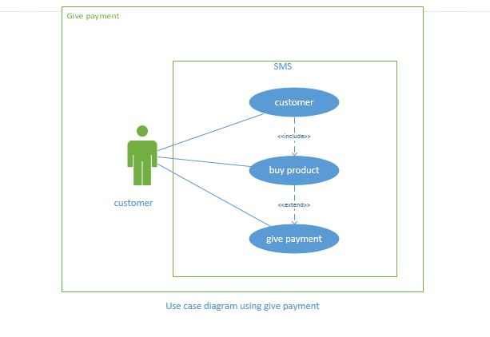
    - Use case description (detail)
    - Give payment (example)
Use Case ID | 6
Name | Give payment
Primary Actor | customer
Secondary Actor | Null
Goal | Customer can give payment
Precondition | Customer order product
Post Condition | Customer receive product
Main Success Scenario | 1.Customer give payment  2.Customer get recit  3.Customer get product
Scenario Extensions | 1. Customer can not give payment  2.Customer can not get recit  3.Customer can not get product

    - Receive money (example)
Cashier can receive money and can give cash memo to the customer
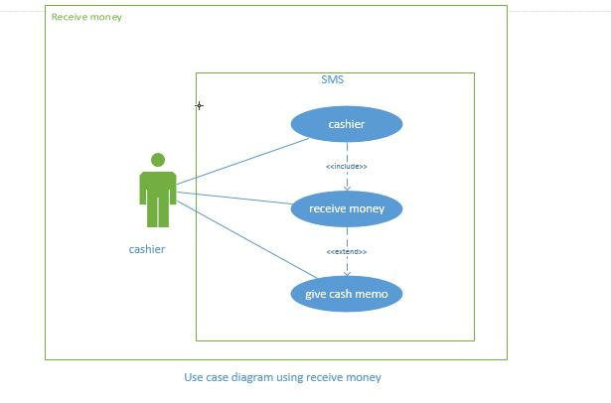
    - Use case description (detail)
    - Receive money example
Use Case ID | 7
Name | Receive money
Primary Actor | cashier
Secondary Actor | customer
Goal | Cashier recive money and give cash memo
Precondition | Sell product to the customer
Post Condition | Receive product
Main Success Scenario | 1.Cashier can receive money  2.Cashier can exchange due to the customer  3.Cashier can give cash memo to the customer
Scenario Extensions | 1. .Cashier can not receive money  2.Cashier can not exchange due to the customer  3.Cashier can not give cash memo to the customer

2.6 System Sequence Diagrams

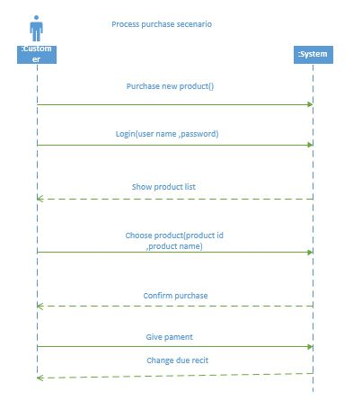

Contract Co1:Purchase new product
Operation: Purchase new product()
Cross Reference: use case: Process purchase
Pre condition: None
Post condition:
1.Go the shop
2.Choose item
3.Give payment
4.Buy product
Contract Co2:Login
Operation :Login(User name, password)
Cross Reference: use case: Process purchase
Pre condition: There is a purchase underway
Post condition:
1.Enter the system
2.View the stock product of the system
3.Choose the product according to their category
Contract Co3:Choose product
Operation: Choose product(product id, product name)
Cross Reference: use case: Process purchase
Pre condition: There is a purchase underway
Post condition:
1.Give payment
2.Purchase product

Contract Co4:Give payment
Operation: Give payment (amount)
Cross Referance: use case: Process purchase
Pre condition: There is a purchase underway
Post condition:
1.Get the product
2.Get the cash memo

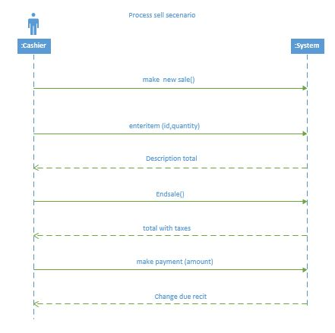
Contract Co1:make new sale
Operation: make new sale()
Cross Referance: use case: Process sale
Pre condition: None
Post condition:
1.a sale instance “s” was created(instance creation)
2. S was associated with register(association form)
3. attributes of s were initialized

Contract Co2:enter item
Operation: enter item(item id, quqntity)
Cross Referance: use case: Process sale
Pre condition: There is a salae underway
Post condition:
1.a salesline item instance was created
2.sli was associated with the current sale(association formed)
3.sli quantity become quantity attribute modification)
4.sli was associated with a product Description,based on item match(association formed)

Contract Co3:end sale
Operation: end sale()
Cross Referance: use case: Process sale
Pre condition: There is a salae underway
Post condition:
1.S is completed became true(attribute modification)

Contract Co4:make payment
Operation: make payment(money)
Cross Referance: use case: Process sale
Pre condition: There is a salae underway
Post condition:
1.a payment instance “p” was created(instance creation)
2.p.amount Tendered became amount (attribute modification)
3.P was associated w.s. sale(association former)
4.S: Sale was associated with the store(association formed)

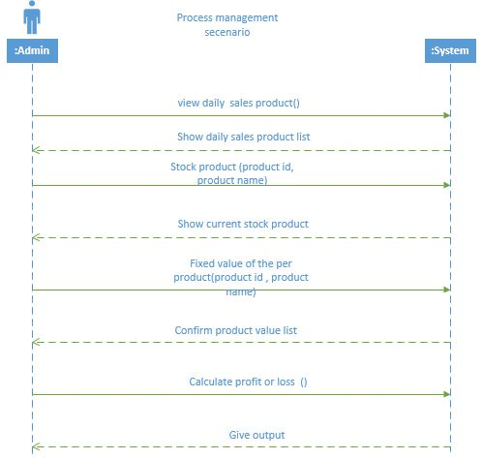

Contract Co1:View daily sales product
Operation:View daily sales product()
Cross Referance: use case: Process management
Pre condition: There is a management of the supershop
Post condition:
1.Get daily sales product list
2.Stock the product
3.Fixed product price
4.Calculate profit or loss

Contract Co2:Stock product
Operation: Stock product(product id ,product name)
Cross Referance: use case: Process management
Pre condition: There is a management of the supershop
Post condition:
1.Fixed value of the stock product
2.Sells stock product according to value per product
Contract Co3:Fixed value of the per product
Operation: Fixed value of the per product t(product id.product name)
Cross Referance: use case: Process management
Pre condition: There is a management of the supershop
Post condition:
1.Sells the product according to the value of per product
2.Calculate profit or loss

Contract Co4:Calculate profit or losss
Operation: Calculate profit or losss()
Cross Referance: use case: Process management
Pre condition: There is a management of the supershop
Post condition:
1.If loss again fixed product value
2.If profit will sell the product according to previous value

2.6.1 purchase new product
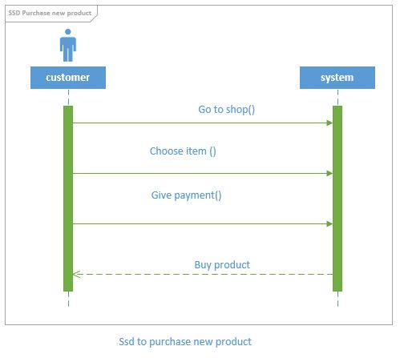

2.6.2 Login
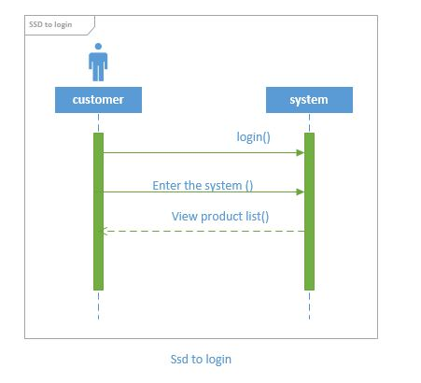
2.6.3 choose product
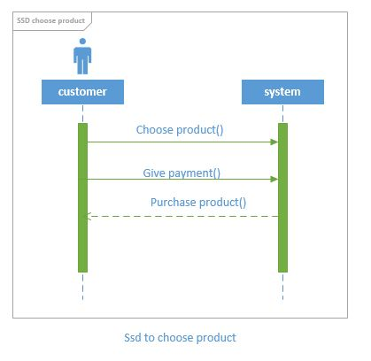

2.6.4 Give payment
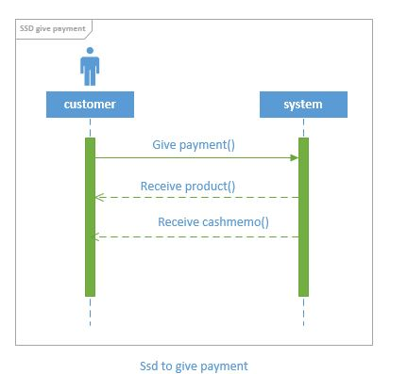
2.6.5 Make new sale
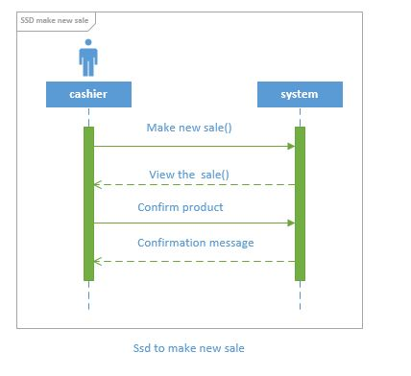

2.6.6 Enter item
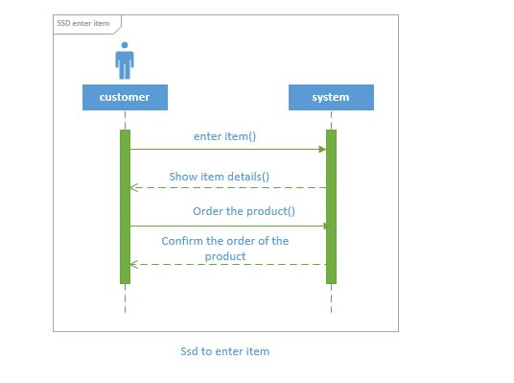
2.6.7 End sale
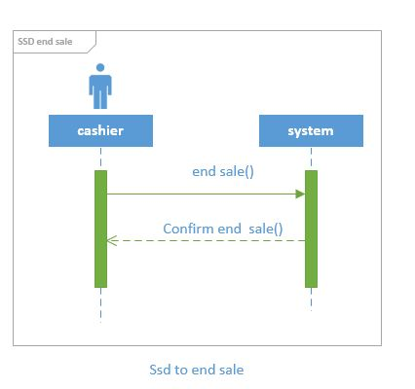

2.6.8 Make payment
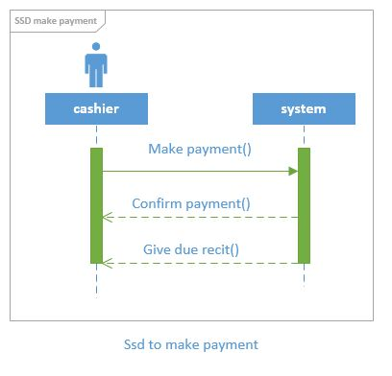
2.6.9 View daily sales product
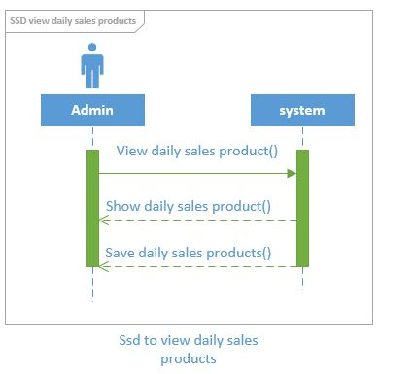

2.6.10 Stock product
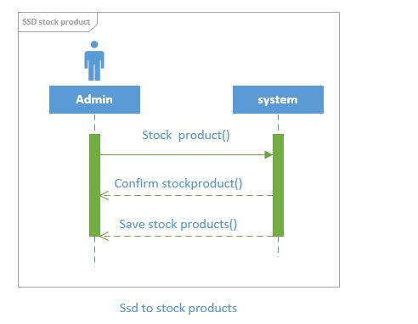

2.6.11 Fixed value of the per product
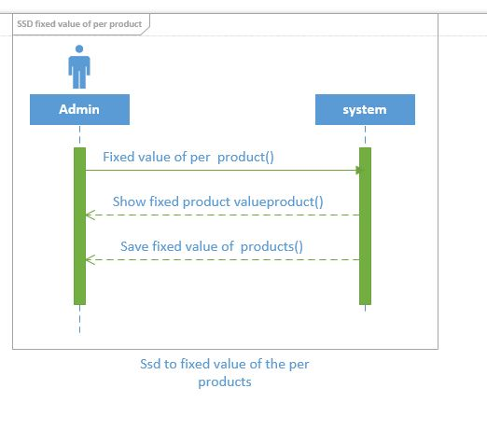

2.6.12 Calculate profit or loss
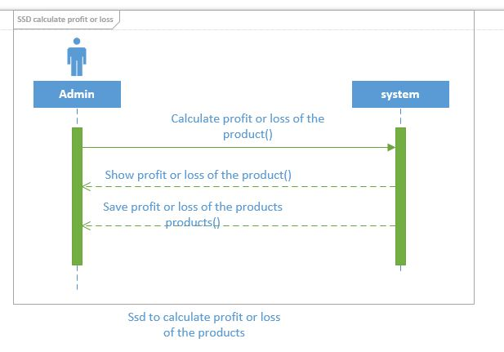

2.7 Domain/Conceptual Model
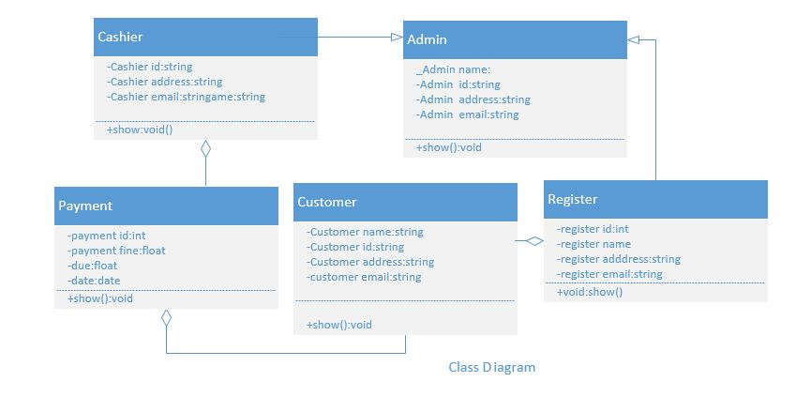

2.8 Activity diagram
Activity diagrams are graphical representations of workflows of stepwise activities and actions with support for choice, iteration and concurrency.
In the system workflows starts from the stage when an applications enters the area of Federal Shariat Court i.e. uploaded in the system to last activity that is a judgment comes or the case is dismissed .This whole process is shown in the below diagram.
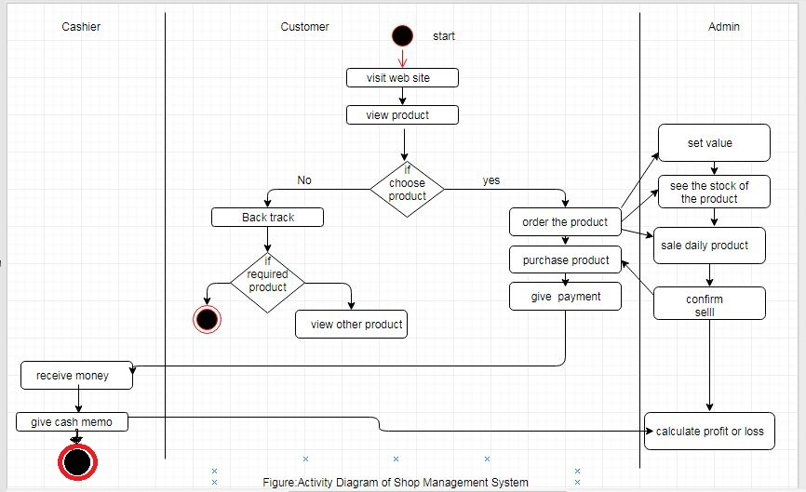

Chapter 3
System Design

3 System Design
Design is a process that uses the product of analysis to produce a specification for implementing a system. Design is the logical description of how a system will work.
Design emphasizes a conceptual solution that fulfills the requirements, rather than its implementation. For example, a description of a database schema and software objects. Design ideas often exclude low-level or "obvious" details obvious to the intended consumers. Ultimately, designs can be implemented, and the implementation (such as code) expresses the true and complete realized design. The term is best qualified, as in object-oriented design or database design.

3.1 Sequence Diagrams
The UML includes interaction diagrams to illustrate how objects interact via messages. They are used for dynamic object modeling. The term interaction diagram is a generalization of two more specialized UML diagram types:
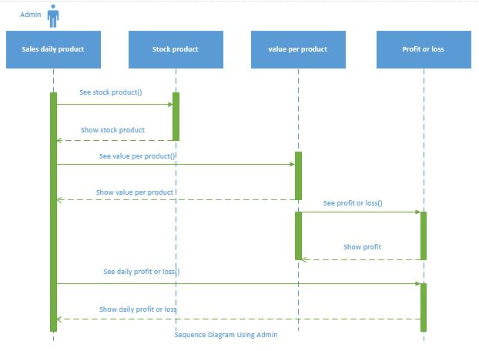
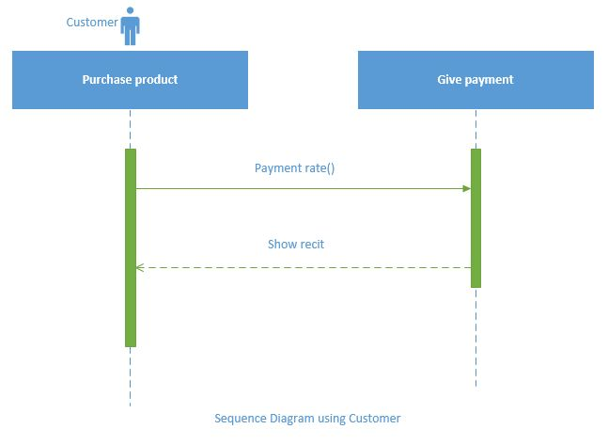
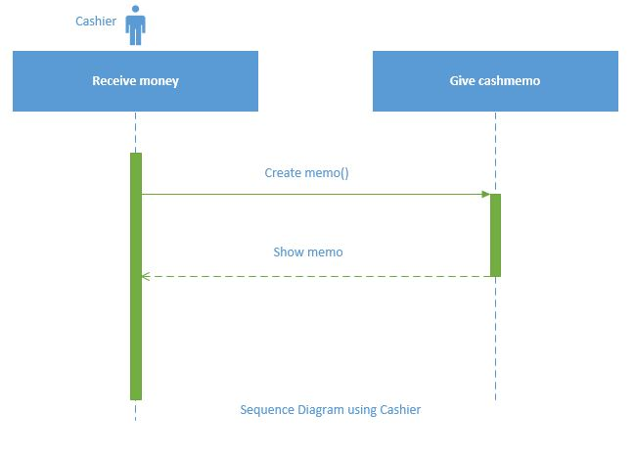

3.1.1 See stock product
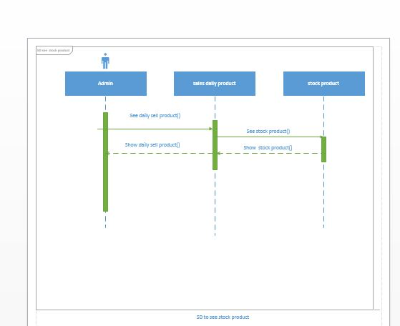

3.1.2 Value per product
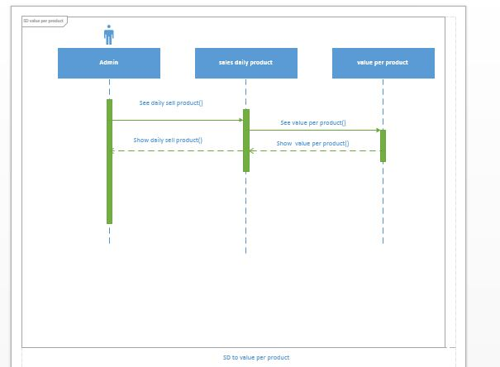

3.1.3 See profit or loss
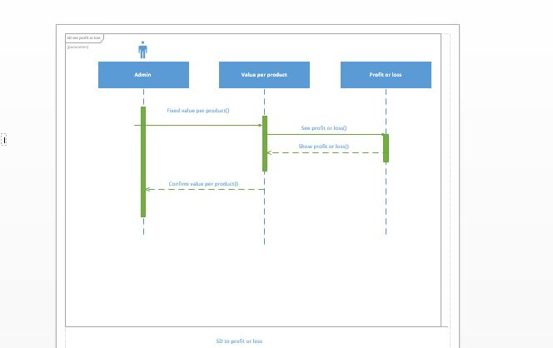

3.1.4 See daily profit or loss
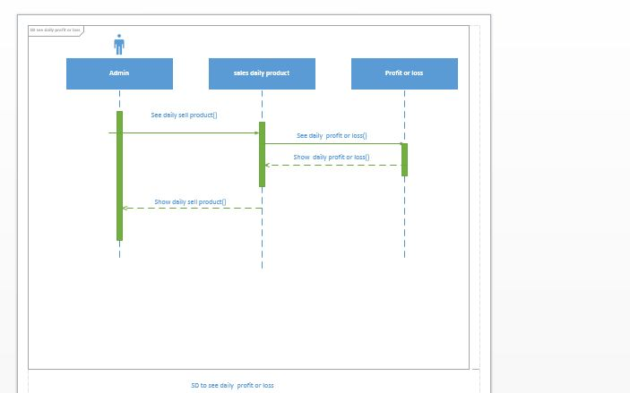

3.1.5 Payment rate
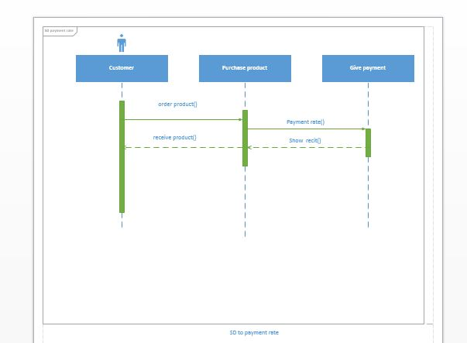

3.1.6 Create memo
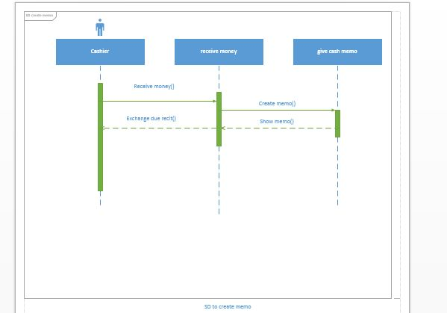

3.2 Class Diagram
Class or structural diagrams define the basic building blocks of a model. They are used for static object modeling, describing what attributes and behavior it has rather than detailing the methods for achieving operations.

3.3 Entity Relationship Diagram
An entity-relationship model is an abstract and conceptual representation of data. Entity-relationship modeling is a database modeling method, used to produce a type of conceptual schema or semantic data model of a system, often a relational database, and its requirements in a top-down fashion.Diagrams created by this process are called Entity Relationship Diagram.
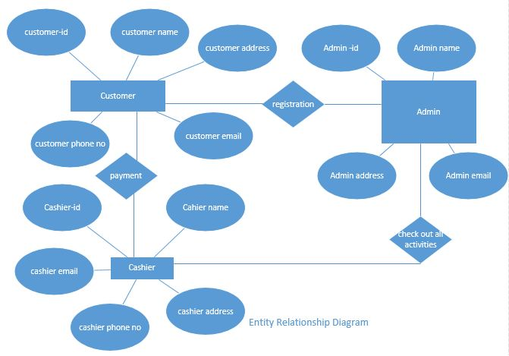

Chapter 4
Implementation

4.Implementation
Implementation (software) perspective describes software implementations in a particular technology (such as C#). In the UP, Implementation means programming and building the system, not deploying it.
In the implementation phase, the developer builds the components either from scratch or by composition given the architecture document from the design phase and the requirement document from the analysis phase. The architecture document should give guidance. Sometimes, this guidance is found in the requirement document. The implementation phase deals with issues of quality, performance and debugging. The end deliverable of implementation phase is the product itself.

4.1 Tools &Technologies
Following are the tools and technologies used in development of this project:
Microsoft Visual Studio 2012
ASP.NET Framework
Microsoft SQL Server 2008
Telerik reports
Microsoft Visio
Microsoft Architect
HTML5, CSS, JavaScript, J-query, Twitter bootstrap

4.2 Project Link
They provide github repository link after uploading the project there.

